**Core Java Assignment 10**

**Assignment on Core Java 11 Features**

**1.**

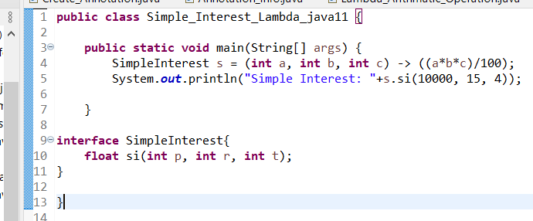

**Output:** Simple Interest: 6000.0

**2.**

//Scenario 1-var cannot be used in an instance and global variable declaration

//as we Cannot make a static reference to the non-static field x

/*class Demo1 {

var x = 50; // instance variable

public static void main(String[] args)

{

System.out.println(x);

}

}

*/

/* Scenario 2-var cannot be used as a Generic type. as it cannot be resolved into perticular type

class Demo2 {

public static void main(String[] args)

{

var<var> al = new ArrayList<>(); // Generic list using var

al.add(10); // add elements

al.add(20);

al.add(30);

System.out.println(al); // print the list

}

}

*/

//Scenario 3-var cannot be used without explicit initialization.

/*as Cannot use 'var' on variable without initializer

Duplicate local variable variable Cannot infer type for local variable initialized to 'null'

class Demo3 {

public static void main(String[] args)

{

var variable; // Declaration without initialization

var variable = null; // This is also not valid

}

}

*/

/*Scenario 4- var cannot be used with Lambda Expression

* var cannot be used since they require explicit target type

* interface myInt {

int add(int a, int b);

}

class Demo4 {

public static void main(String[] args)

{

var obj = (a, b) -> (a + b); // var cannot be used since they require explicit target type

System.out.println(obj.add(2, 3)); // calling add method

}

}

//Scenario 5-var cannot be used for method parameters and return type

* class Demo8 {

// method1 using var

// as a return type

var method1() { return ("Inside Method1"); }

// method2 using var for a

// parameter

void method2(var a) { System.out.println(a); }

public static void main(String[] args)

{

Demo1 obj = new Demo1(); // create an instance

var res = obj.method1(); // call method1

obj.method2(); // call method2

}

}

*/

**public** **class** Assignment10_Java11_Q2_var {

**public** **static** **void** main(String[] args) {

}

}

**3.**

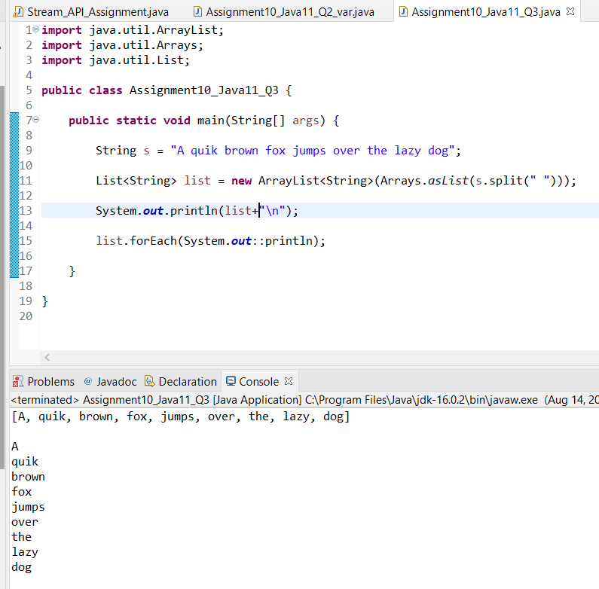

**4.**

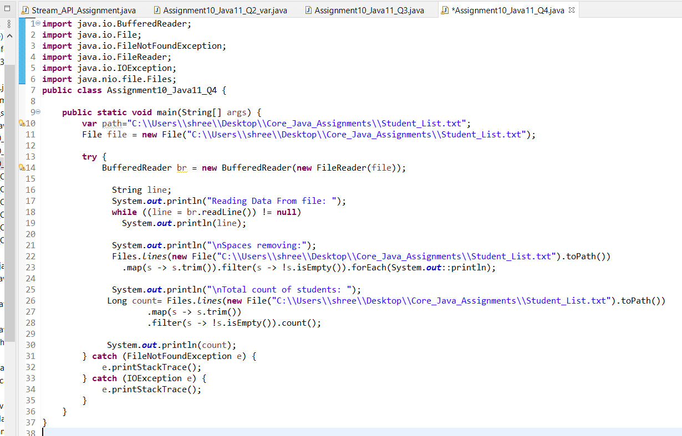

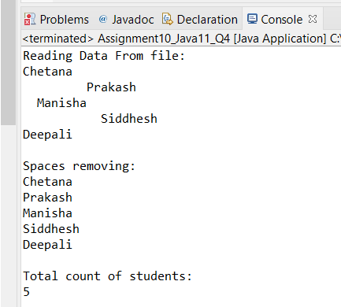

**5.**

**import** java.io.*;

**import** java.util.*;

**class** item {

String name, id;

**int** qty;

**double** price, total;

item(String i, String n, String q, String p) {

name = n;

id = i;

qty = Integer.*parseInt*(q);

price = Double.*parseDouble*(p);

total = qty * price;

}

**public** String toString() {

String s = name + " " + id + " " + qty + " " + price + " " + total;

**return** (s);

}

**public** **static** **void** search(item[] arr, **int** n) **throws** IOException {

BufferedReader br = **new** BufferedReader(**new** InputStreamReader(System.***in***));

String s = br.readLine();

**for** (**int** i = 0; i < n; i++) {

**if** (arr[i].name.equals(s)) {

System.***out***.println(arr[i].toString());

**return**;

}

}

System.***out***.println("No Records Found");

}

**public** **static** **void** searchc(item[] arr, **int** n) {

**double** max = 0;

**int** c = 0;

**for** (**int** i = 0; i < n; i++) {

**if** (arr[i].price > max) {

c = i;

}

}

System.***out***.println(arr[c].toString());

}

}

**public** **class** Assignment10_Java11_Q5 {

**public** **static** **void** main(String[] args) **throws** IOException {

String s, space = " ";

**int** c, i;

BufferedReader b = **new** BufferedReader(**new** InputStreamReader(System.***in***));

System.***out***.println("Enter Number of Product Records:");

**int** n = Integer.*parseInt*(b.readLine());

System.***out***.println("1: Insert Product Records:\n<id> <name> <price> <qty> :");

FileWriter f = **new** FileWriter("item.dat");

**for** (i = 0; i < n; i++) {

s = b.readLine() + "\n";

f.write(s);

}

f.close();

item it[] = **new** item[20];

FileReader fr = **new** FileReader("item.dat");

BufferedReader br = **new** BufferedReader(fr);

**for** (i = 0; i < n; i++) {

s = br.readLine();

StringTokenizer t = **new** StringTokenizer(s, space);

String si = **new** String(t.nextToken());

String sn = **new** String(t.nextToken());

String sq = **new** String(t.nextToken());

String sp = **new** String(t.nextToken());

it[i] = **new** item(si, sn, sq, sp);

}

**do** {

System.***out***.println("Menu :\n" + "2:View Purchase Total \n3:Exit\n" + "Choice :");

c = Integer.*parseInt*(b.readLine());

**switch** (c) {

**case** 2:

**for** (i = 0; i < n; i++)

System.***out***.println(it[i].toString());

**break**;

**case** 3:

System.***out***.println("Exit Program...");

**break**;

**default**:

System.***out***.println("Invalid Option");

}

} **while** (c != 3);

}

}

**6.**

